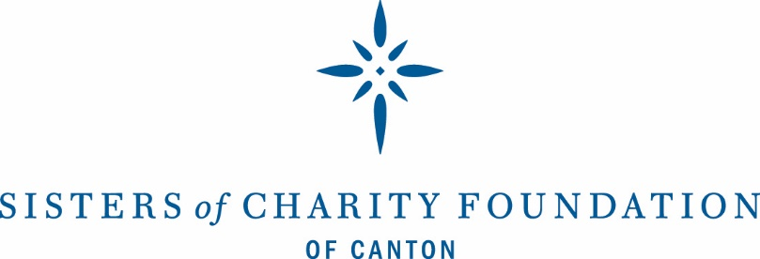

**Strategic Goals 2020**

1. Strengthen efforts to end homelessness in Stark County by providing strategic leadership and investing in the Stark Housing Network and direct service organizations.
2. Advance early childhood efforts through local, state, and national work that ensures the Foundation and its partners understand current best practices and are aware of opportunities to improve school readiness of low-income children.
3. Strengthen Stark County’s mental health organizations by offering targeted and specific technical assistance and capacity building assistance to ensure high-quality services are available to those in need.
4. Improve the mental health system by working with local partners, state departments, and Stark Mental Health and Addiction Recovery to ensure strong, financially sound organizations are in place to serve those in need.
5. Improve health outcomes for Stark County residents by offering oversight and evaluation support to efforts that promote healthy living, reduce infant mortality, and address chronic disease.
6. Expand promising local efforts that increase employment among those who are chronically unemployed and underemployed through coalition building, funding, research, and data analysis.
7. Strengthen the organizational capacity of Stark County nonprofit and government agencies that are critical to the overall health of the community by offering technical assistance and leadership development that will improve and sustain programs and services.
8. Develop a new approach for improving educational outcomes for Stark County children and youth by studying national trends, connecting with local school districts and child-serving organizations, and determining where the Foundation can make the greatest impact.
9. Ensure community needs are met by responding to requests to fund and participate in work that advances the Foundation’s mission.
10. Improve the Foundation’s work by upgrading grantmaking processes, communication efforts, and staff knowledge so that grantees and partners are supported and informed.